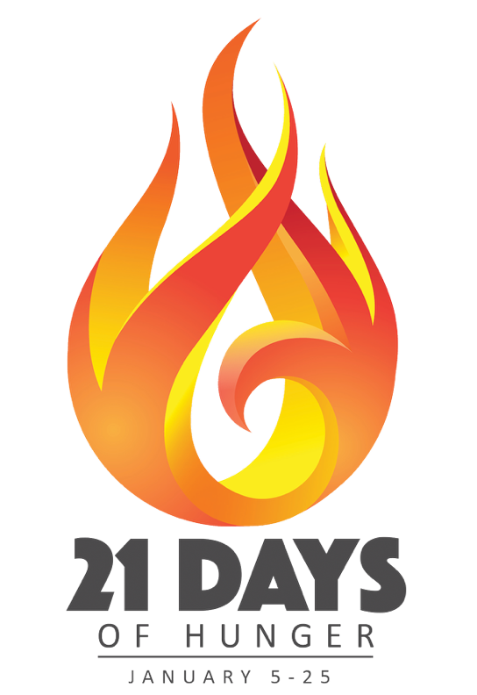

PLEASE JOIN OUR CHURCH FAMILY AND CONGREGATIONS ACROSS NEW YORK
FOR 21 DAYS OF FASTING, PRAYER, AND SEEKING GOD.

Starting January 5, 2026, and continuing through January 25, 2026, we are calling our church family to a season of prayer and fasting entitled, “21 Days of Hunger.” We sincerely hope you will join us for three sacred weeks of seeking God for a greater outpouring of His Spirit, a deeper revelation of His Word, and a renewal of our hunger for God in church and in our lives!
Each person is encouraged to fast in a way that best suits their lifestyle. It could be a “Daniel Fast,” a fast that abstains from one meal a day or fasting from dawn to dusk. The type of fast is up to you, we simply hope you’ll participate in a way that unites us in a collective cry of hunger to God.
It’s important during this time of corporate fasting to stay connected with the body. Join us Monday Through Friday on our 5am Morning Prayer Call, Tuesday Nights at 7pm for our Tuesday Night Virtual Prayer Meetings, as well as our Wednesday Night Bible Study at 7pm. We also want to invite you to come out on Sunday, January 11th & 18th at 6pm in the Sanctuary for a time of Corporate Prayer as we come together as One Body to Seek the Lord.
This season of prayer and fasting will come to an exciting conclusion on Sunday, January 25 at 6 pm with a special Celebration of Praise streamed live from The Mission Church. This will be an awesome event with powerful worship, energetic praise, Holy Spirit-inspired preaching, and earth-shaking prayer! You can join this event virtually with churches from across the NYMN.
Please mark your calendar today and plan to join us for 21 Days of Hunger. Check out our website, www.hempsteadassembly.org for more details. God has good plans for you and good plans for this Church. Let’s get hungry for the presence of God!
Sincerely,

Rev. Jordan-Anthony Channer

